2 RTB OFFICERS & SERGEANTS MESSES – See note below
2 RTB SERGEANTS MESS
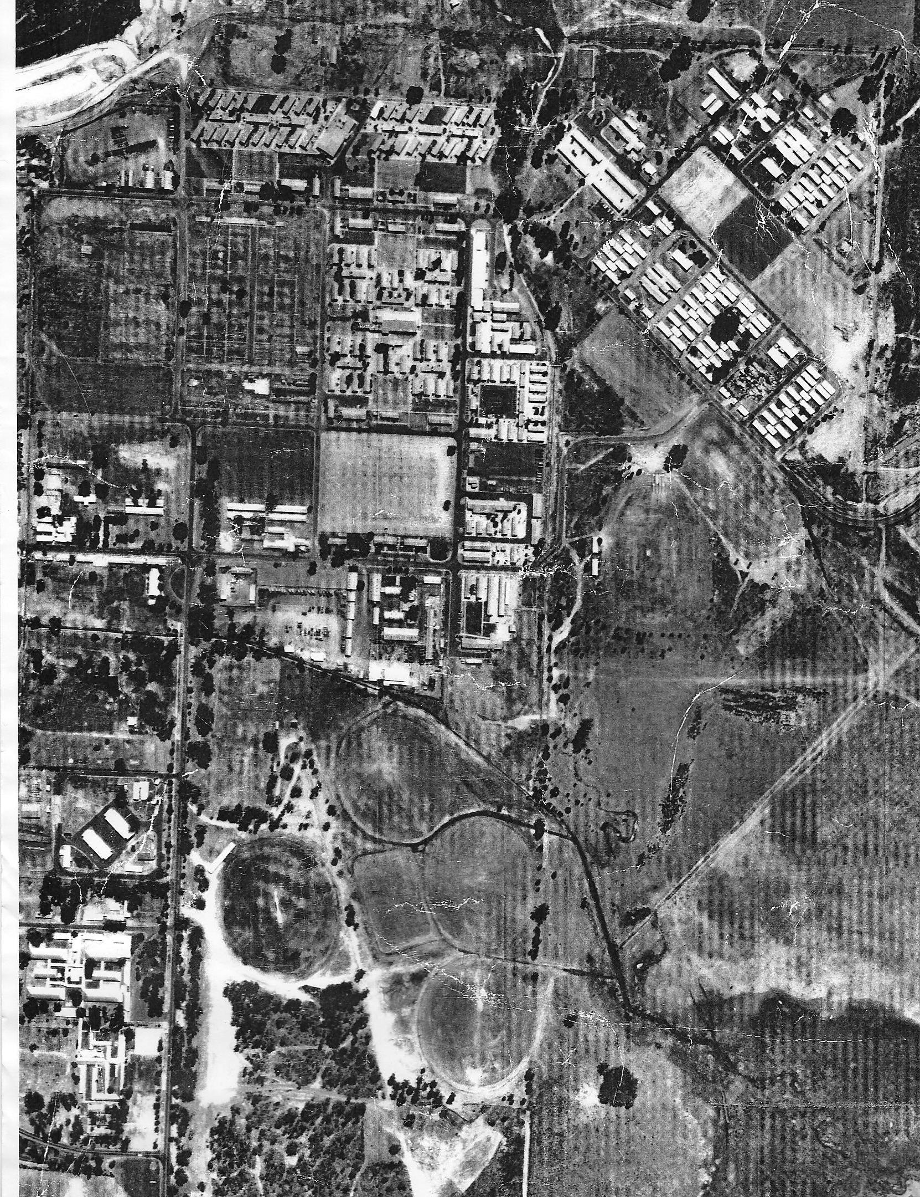
B Coy

and

A Coy
S BLOCK 22 RVR CMF
BHQ
D Coy and C Coy
21 CONSTR SQN ARA
2 RTB OFFICERS MESS

The Q Store and ARA Staff were located in the buildings to the right of the Parade Ground and A and B Company lines backing onto the creek/drain.

